***Solution Section* 1.5– Mixing Problems**

***Exercise***

Consider two tanks, label tank *A* and tank *B* for reference. Tank *A* contains 100 *gal* of solution in which is dissolved 20 *lb* of salt. Tank *B* contains 200 *gal* of solution which is dissolved 40 *lb* of salt. Pure water flows into the tank *A* at rate of 5 *gal/s*. There is a drain at the bottom of tank *A*. The solution leaves tank *A* via the drain at a rate of 5 *gal/s* and flows immediately into tank *B* at the same rate. A drain at the bottom of tank *B* allows the solution to leave tank *B* at a rate of 2.5 *gal/s*. What is the salt content in tank *B* at the precise moment that tank *B* contains 250 *gal* of solution?

***Solution***

Tank ***A*** contains 100 *gal* of solution in which is dissolved 20 *lb* of salt

*Volume*: 

Concentration at time *t*: 

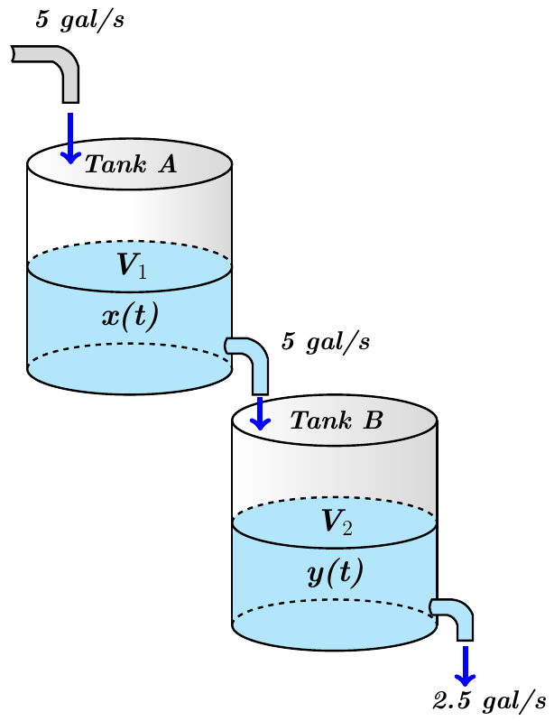 Rate out = Volume Rate *x* Concentration



















 



Tank ***B*** contains 200 *gal* of solution which is dissolved 40 *lb* of salt.

*Volume*: 





























 



 





















 











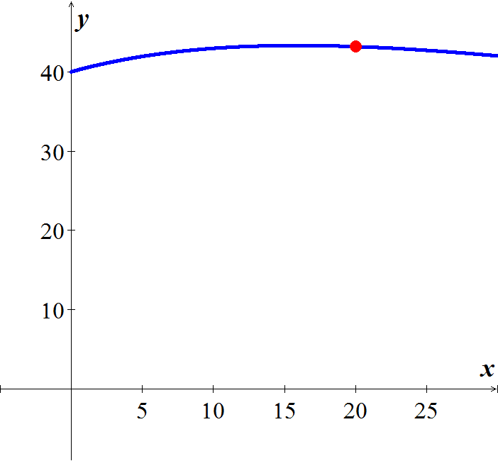

***Exercise***

A tank contains 100 *gal* of pure water. At time zero, a sugar-water solution containing 0.2 *lb* of sugar per gal enters the tank at a rate of 3 *gal/min*. Simultaneously, a drain is opened at the bottom of the tank allowing the sugar solution to leave the tank at 3 *gal/min*. Assume that the solution in the tank is kept perfectly mixed at all times.

1. What will be the sugar content in the tank after 20 *minutes*?
2. How long will it take the sugar content in the tank to reach 15 *lb*?
3. What will be the eventual sugar content in the tank?

***Solution***

1. 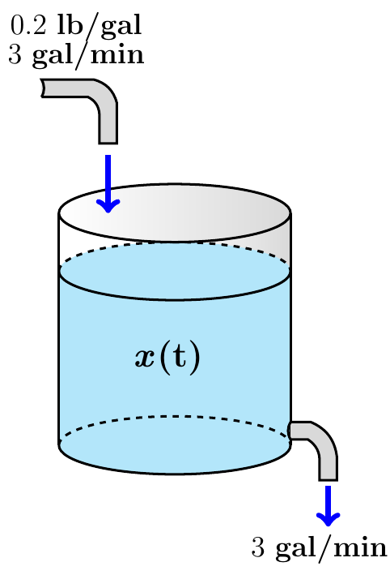

 

















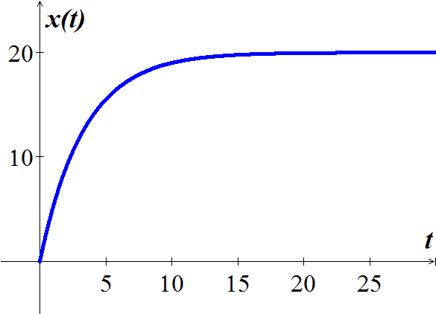





1. 











1. 



***Exercise***

A tank initially contains 50 *gal* of sugar water having a concentration of 2 *lb*. of sugar for each gal of water. At time zero, pure water begins pouring into the tank at a rate of 2 *gal* per *minute*. Simultaneously, a drain is opened at the bottom of the tank so that the volume of sugar-water solution in the tank remains constant.

1. How much sugar is in the tank after 10 *minutes*?
2. How long will it take the sugar content in the tank to dip below 20 *lb*.?
3. What will be the eventual sugar content in the tank?

***Solution***

 represents the number of pounds of sugar.

1. 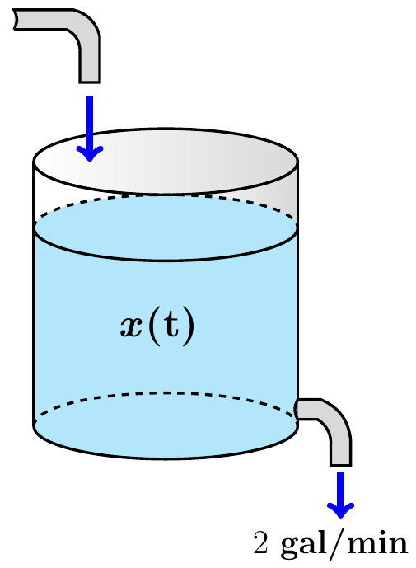









The initial condition: 





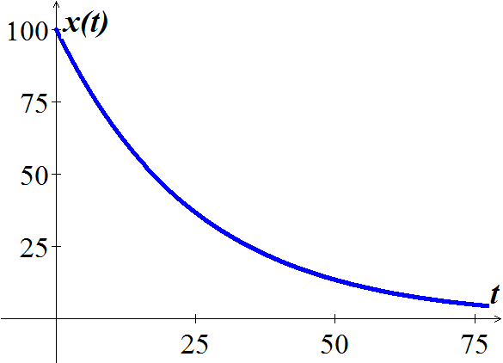



1. 









1. 



***Exercise***

A 50-*gal* tank initially contains 20 *gal* of pure water. Salt-water solution containing 0.5 *lb* of salt for each gallon of water begins entering the tank at a rate of 4 *gal/min*. Simultaneously, a drain is opened at the bottom of the tank, allowing the salt-water solution to leave the tank at a rate of 2 *gal/min*. What is the salt content (*lb*) in the tank at the precise moment that the tank is full of salt-water solution?

***Solution***

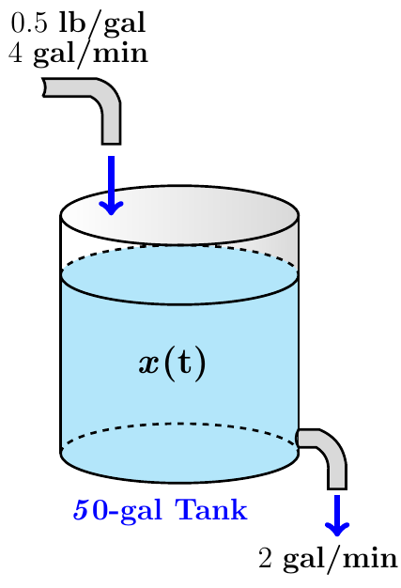











 



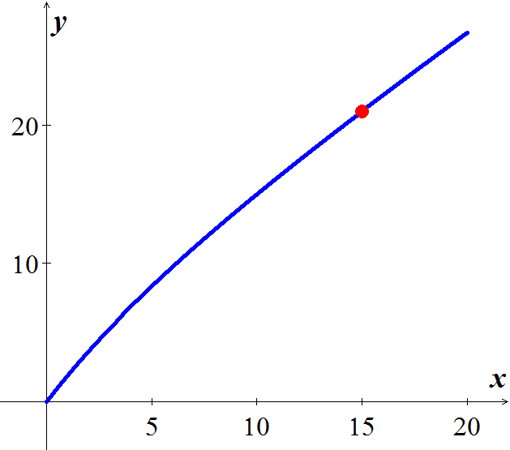 

















Full tank: 









***Exercise***

A tank contains 500 *gal* of a salt-water solution containing 0.05 *lb* of salt per gallon of water. Pure water is poured into the tank and a drain at the bottom of the tank is adjusted so as to keep the volume of solution in the tank constant. At what rate (*gal*/*min*) should the water be poured into the tank to lower the salt concentration to 0.01 *lb/gal* of water in less than one hour?

***Solution***



















The concentration at time *t* is given by: 

The concentration reaches 1% in one hour or 60 minutes.











***Exercise***

Suppose that a large tank initially holds 300 *gallons* of water in which 50 *pounds* of salt have been dissolved. Pure water is pumped into the tank at a rate of 3 *gal/min*, and when the solution is well stirred, it is then pumped out at the same rate. Determine a differential equation for the amount of salt  in the tank at time .

***Solution***





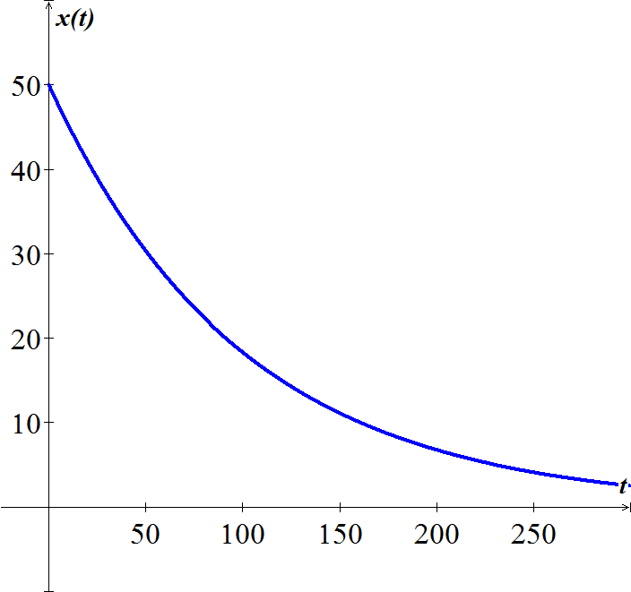











 









***Exercise***

Suppose that a large mixing tank initially holds 300 *gallons* of water is which 50 *pounds* of salt have been dissolved. Another brine solution is pumped into the tank at a rate of 3 *gal/min*, and when the solution is well stirred, it is then pumped out at a slower rate if 2 *gal/min*. If the concentration of the solution entering is 2 *lb/gal*, determine a differential equation for the amount of salt  in the tank at time 

***Solution***





























***Exercise***

Suppose that a large mixing tank initially holds 300 *gallons* of water is which 50 *pounds* of salt have been dissolved. Another brine solution is pumped into the tank at a rate of 3 *gal/min*, and when the solution is well stirred, it is then pumped out at a faster rate if 3.5 *gal/min*. If the concentration of the solution entering is 2 *lb/gal*, determine a differential equation for the amount of salt  in the tank at time .

***Solution***







































***Exercise***

A tank contains 100 *gal* of fresh water. A solution containing 1 *lb./gal* of soluble lawn fertilizer runs into the tank at the rate of 1 *gal/min*, and the mixture is pumped out of the tank at a rate of 3 *gal/min*. Find the maximum amount of fertilizer in the tank and the time required to reach the maximum.

***Solution***

Volume of the tank at time *t* is:

















































The maximum amount is:





***Exercise***

A 200-*gal* tank is half full of distilled water. At time *t* = 0, a solution containing 0.5 *lb./gal* of concentrate enters the tank at the rate of 5 *gal/min*, and the well-stirred mixture is withdrawn at the rate of 3 *gal/min*.

1. At what time will the tank be full?
2. At the time the tank is full, how many pounds of concentrate will it contain?

***Solution***

1. 





1. Let *y*(*t*) be the amount of concentrate in the tank at time *t*.

























 









***Exercise***

A 1500 *gallon* tank initially contains 600 *gallon* of water with 5 *lbs*. of salt dissolved in it. Water enters the tank at a rate of 9 *gal/hr.* and the water entering the tank at a rate has a salt concentration of  *lbs./gal*. If a well mixed solution leaves the tank at a rate of 6 *gal/hr.*, how much salt is in the tank when it overflows?

***Solution***

***Given***: 









|  |  |  |
| --- | --- | --- |
|  |  |  |
| + |  |  |
| − |  |  |
| + |  |  |



























The amount of salt in the full tank is 

***Exercise***

Suppose that an Iowa class battleship has mass 51,000 *metric* *tons* (51,000,000 *kg*) and . Assume that the ship loses power when it is moving at a speed of 9 *m/sec*.

1. About how far will the ship coast before it is dead in the water?
2. About how long will it take the ship’s speed to drop to 1 *m/sec*?

***Solution***



1. 





















The ship will coast about 7780 *meters* or 7.78 *km*.

1. 









It will take about 

***Exercise***

A 66-*kg* cyclist on a 7-*kg* bicycle starts coasting on level ground at 9 *m/sec*. The 

1. About how far will the cyclist coast before reaching a complete stop?
2. How long will it take the cyclist’s speed to drop to 1 *m/sec*?

***Solution***

Mass: 



1. 























The cyclist coast about 168.5 *meters*.

1. 







It will take about 41.13 *seconds*.

***Exercise***

An Executive conference room of a corporation contains 4500  of air initially free of carbon monoxide. Starting at time *t* = 0, cigarette smoke containing 4% carbon monoxide is blown into the room at the rate of 0.3 . A ceiling fan keeps the air in the room well circulated and the air leaves the room at the same rate of 0.3 . Find the time when the concentration of carbon monoxide in the room reaches 0.01%.

***Solution***

Let  be the amount of carbon monoxide (CO) in the room at time *t*.

























When the concentration of CO is 0.01% in the room, the amount of CO satisfies



When the room contains the amount 













***Exercise***

Consider the cascade of 2 tanks with  and  the volumes of brine in the 2 tanks. Each tank also initially contains 50 *lb*. of salt. The three flow rates indicated in the figure are each 5 *gal/min*, with pure water flowing into tank.

1. Find the amount  of salt in tank 1 at time *t*.
2. Suppose that  is the amount of salt in tank 2 at time *t*. Show first that



And then solve for , using the function  found in part (*a*).

1. Finally, find the maximum amount of salt ever in tank 2.

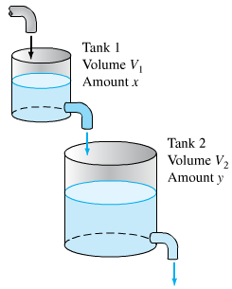***Solution***

1. 















1. 

















With 









1. The maximum value of *y* occurs when















***Exercise***

Suppose that in the cascade tank 1 initially 100 *gal* of pure ethanol and tank 2 initially contains 100 *gal* of pure water. Pure water flows into tank 1 at 10 *gal/min*, and the other two flow rates are also 10 gal/min.

1. Find the amounts  and  of ethanol in the two tanks at time  .
2. Find the maximum amount of ethanol ever in tank 2.

***Solution***

1. The initial value problem 

For ***Tank*** 1:



















The initial value problem 

For ***Tank*** 2:



















1. The maximum value of *y* occurs when







Thus when *t* = 10,







***Exercise***

A multiple cascade is shown in the figure. At time *t* = 0, tank 0 contains 1 *gal* of ethanol and 1 *gal* of water; all the remaining tanks contain 2 *gal* of pure water each. Pure water is pumped into tank 0 at 1 *gal/.min*, and the varying mixture in each tank is pumped into the one below it at the same rate. Assume, as usual, that the mixtures are kept perfectly uniform by stirring. Let  denote the amount of ethanol in tank *n* at time *t*.

1. Show that 
2. Show that the maximum value of  for *n* > 0 is 

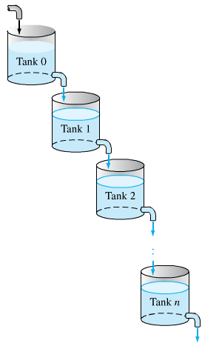***Solution***

1. For ***Tank*** **0**: 

















1. Using the induction

For ***n* = 0**, then  ***√*** True

Assume it is true for *n*: 

We need to prove that the equation for

 is also true.



























 ***√*** It is also true

1. 













***Exercise***

Assume that Lake Erie has a volume of 480  and that its rate of inflow (from Lake Huron) and outflow (to Lake Ontario) are both 350  per year. Suppose that at the time *t* = 0 (years), the pollutant concentration of Lake Erie – caused by past industrial pollution that has now been ordered to cease – is 5 times that of Lake Huron. If the outflow henceforth is perfectly mixed lake water, how long will it take to reduce the pollution concentration in Lake Erie to twice that of Lake Huron?

***Solution***

***Given***: *V* = 480 



 (The pollutant concentration of Lake Huron)

























When is 















***Exercise***

A 120 *gal* tank initially contains 90 *lb*. of salt dissolved in 90 *gal* of water. Brine containing 2 *lb./gal* of salt flows into the tank at rate of 4 *gal/min*, and the well-stirred mixture flows out the tank at the rate of 3 *gal/min*. How much salt does the tank contain when it is full?

***Solution***

The volume of brine in the tank increase steadily with: 

The change  in the amount *x* of salt in the tank from time *t* to time  is given by:

































The tank is full after 30 min, Therefore when *t* = 30,







The tank contains 202 *lb*. of salt.

***Exercise***

A 1000 *gallon* holding tank that catches runoff from some chemical process initially has 800 *gallons* of water with 2 *ounces* of pollution dissolved in it. Polluted water flows into the tank at a rate of 3 *gal/hr*. and contains 5 *ounces/gal* of pollution in it. A well mixed solution leaves the tank at 3 *gal/hr*. as well. When the amount of pollution in the holding tank reaches 500 *ounces* the inflow of polluted water is cut off and fresh water will enter the tank at a decreased rate of 2 *gallons* while the outflow is increased to 4 *gal/hr*. Determine the amount of pollution in the tank at time *t*.

***Solution***

 the time when maximum amount of pollution is reached.

 Volume when maximum amount of pollution is reached.

 the time when tank is empty.

Let  be the amount (in *ounces*) of additive in the tank at time *zero*and 

Let  be the amount (in *ounces*) of additive in the tank at timeand 











When the maximum amount of pollution is reached:





After the maximum amount of pollution is reached:













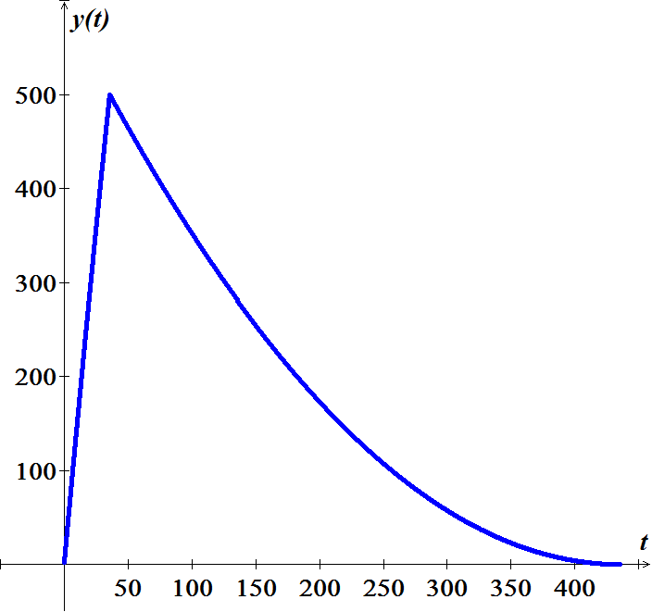 





































***Exercise***

A tank contains 50 *gallons* of a solution composed of 90% water and 10% alcohol. A second solution containing 50% water and 50% alcohol is added to the tank at the rate of . As the second solution is being added, the tank is being drained at a rate of . The solution in the tank is stirred constantly. How much alcohol is in the tank after 10 *minutes*?

***Solution***

Let *y* be the amount (in *lb*.) of additive in the tank at time *t* and 









































***Exercise***

A 200-*gallon* tank is half full of distilled water. At time , a concentrate solution containing  enters the tank at the rate of , and well-stirred mixture is withdrawn at the rate of .

1. At what time will the tank be full?
2. At the time the tank is full, how many pounds of concentrate will it contain?

***Solution***

1. 



1. 

 































***Exercise***

A 200-*gallon* tank is half full of distilled water. At time , a concentrate solution containing  enters the tank at the rate of , and well-stirred mixture is withdrawn at the rate of .

1. At what time will the tank be full?
2. At the time the tank is full, how many pounds of concentrate will it contain?

***Solution***

1. 



1. 





































***Exercise***

A 200-*gallon* tank is full of a concentrate solution containing . Starting at time , distilled water is admitted to the tank at the rate of , and well-stirred mixture is withdrawn at the same rate.

1. Find the amount of concentrate in the solution as a function of *t*.
2. Find the time at which the amount of concentrate in the tank reaches 15 *pounds*.
3. Find the quantity of the concentrate in the solution as .

***Solution***

1. 

















1. 









1. 



***Exercise***

A 500-*gallon* tank is full of a concentrate solution containing . Starting at time , distilled water is admitted to the tank at the rate of , and well-stirred mixture is withdrawn at the rate .

1. At what time will the tank be empty?
2. Find the amount of concentrate in the solution as a function of *t*.

***Solution***

1. 







It will take 100 *minutes* to empty the tank.

1. 















***Exercise***

A tank contains 300 *litres* of fluid in which 20 *grams* of salt is dissolved. Brine containing 1 *g* of salt per *litre* is then pumped into the tank at a rate of 4 *L/min*; the well-mixed solution is pumped out at the same rate. Find the number  of grams of salt in the tank at time *t*.

***Solution***







Let *y* be the amount (in *g*.) of additive in the tank at time *t* and























***Exercise***

A 100-*gallon* tank is full of a concentrate solution containing . Starting at time , Brine containing  is then pumped into the tank at a rate of , and well-stirred mixture is withdrawn at the rate. Find the amount of concentrate in the solution as a function of *t*.

***Solution***





Let *y* be the amount (in *lb*.) of additive in the tank at time *t* and























***Exercise***

A 10-*gallon* tank is full of a concentrate solution containing . Starting at time , Brine containing  is then pumped into the tank at a rate of , and well-stirred mixture is withdrawn at the rate.

1. Find the amount of concentrate in the solution as a function of *t*.
2. Find the quantity of the concentrate in the solution as .

***Solution***

1. 



Let *y* be the amount (in *lb*.) of additive in the tank at time *t* and























1.  



***Exercise***

A tank contains 200 *liters* of fluid in which 30 *grams* of salt is dissolved. Brine containing 1 *gram* of salt per liter is then pumped into the tank at a rate of 4 *L/min*; the well-mixed solution is pumped out at the same rate.

1. Find the number  of grams of salt in the tank at time *t*.
2. Solve by assuming that pure water is pumped into the tank.

***Solution***

1. 



















***Given***: 





1. 









***Given***: 



***Exercise***

A large tank is filled to capacity with 500 *gallons* of pure water. Brine containing 2 *pounds* of salt per gallon is pumped into the tank at a rate of 5 *gal/min*. The well-mixed solution is pumped out at the same rate.

1. Find the number  of grams of salt in the tank at time *t*.
2. What is the concentration  of the salt in the tank at time *t*? At time ?
3. What is the concentration of the salt in the tank after a long time, that is, as ?
4. What is the concentration of the salt in the tank equal to one-half this limiting value?
5. Solve under assumption that the solution is pumped out at a faster rate of 10 *gal/min*. when tis the tank empty?

***Solution***

1. 























***Given***: 



1. 





1. 



1. 







1. 





























***Given***: 





 

The tank is empty in 

***Exercise***

A large tank is filled to capacity with 100 *gallons* of fluid in which 10 *pounds* of salt is dissolved. Brine containing  *pound* of salt per gallon is pumped into the tank at a rate of 6 *gal/min*. The well-mixed solution is pumped out at the slower rate of 4 *gal/min*. Find the number of pounds of salt in the tank after 30 *minutes*.

***Solution***





















***Given***: 









***Exercise***

A 5000-*gal* tank is maintained with a pumping system that passes 100 *gal* of water per minute through the tank. To treat a certain fish malady, a soluble antibiotic is introduced into the inflow system. Assume that the inflow concentration of medicine is  *mg/gal*, where *t* is measured in *minutes*. The well-stirred mixture flows out of the tank at the same rate.

1. Solve for the amount of medicine in the tank as function of time.
2. What is the maximum concentration of medicine achieved by this dosing and when does it occur?
3. For the antibiotic to be effective, its concentration must exceed 100 *mg/gal* for a minimum of 60 *min*. was the dosing effective?

***Solution***

1. 

























1. 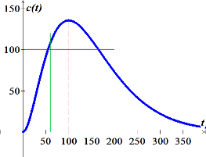





The maximum concentration







1. From the graph, the dosing was effective.





***Exercise***

A tank initially contains 400 *gal* of fresh water. At time , a brine solution with a concentration of 0.1 *lb*. of salt per gallon enters the tank at a rate of 1 *gal/min* and the well-stirred mixture flows out at a rate of 2 *gal/min*.

1. How long does it take for the tank to become empty?
2. How much salt is present when the tank contains 100 *gal* of brine?
3. What is the maximum amount of salt present in the tank during the time interval found in part (*a*)?
4. When is the maximum achieved?

***Solution***

1. 





1. 





































1. 











1. 

***Exercise***

A tank, having a capacity of 700 *gal*, initially contains 10 *lb*. of salt dissolved in 100 *gal* of water. At time , a solution containing 0.5 *lb*. of salt per gallon flows into the tank at a rate of 3 *gal/min* and the well-stirred mixture flows out of the tank at a rate of 2 *gal/min*.

1. How much time will elapse before the tank is filled to capacity?
2. What is the salt concentration in the tank when it contains 400 *gal* of solution?
3. What is the salt concentration at the instant the tank is filled to capacity?

***Solution***

1. 



1. 







































 



1. 



 



***Exercise***

A 500-*gal* aquarium is cleansed by the recirculating filter system schematically shown in the figure.

Water containing impurities is pumped out at a rate of 15 *gal/min*, filtered, and returned to the aquarium at the same rate. Assume that passing through the filter reduces the concentration of impurities by a fractional amount *α*. In the other words, if the impurity concentration upon entering the filter is , the exit concentration is , where .

1. Apply the basic conservation principle  to obtain a differential equation for the amount of impurities present in the aquarium at time *t*. Assume that filtering occurs instantaneously. If the outflow concentration at any time is , assume that the inflow concentration at that same instant is .
2. What value of filtering constant *α*. will reduce impurity levels to 1% of their original values in a period of 3 *hr.*?

***Solution***

1. 





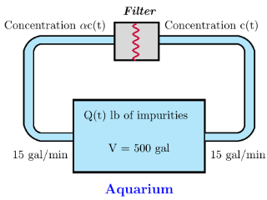

1. 

















***Exercise***

A mixing chamber initially contains 2 *gal* of a clear fluid. Clear fluid flows into the chamber at a rate of 10 *gal/min*. A dye solution having a concentration of 4  is injected into the mixing chamber at a rate of *r* *gal/min*. When the mixing process is started, the well-mixed mixture is pumped from the chamber at a rate .

1. Develop a mathematical model for the mixing process.
2. The objective is to obtain a dye concentration in the outflow mixture of 1 . What injection rate *r* is required to achieve this equilibrium solution? Would this equilibrium value of *r* be different if the fluid in the chamber at time  contained some dye?
3. Assume the mixing chamber contains 2 *gal* of clear fluid at time . How long will it take for the outflow concentration to rise to within 1% of the desired concentration?

***Solution***

1. 

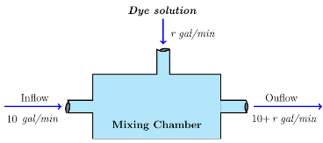









1. 







1. 















 



















***Exercise***

Suppose a brine containing 0.2 *kg* of salt per liter runs into a tank initially filled with 500 *L* of water containing 5 *kg* of salt The brine enter the tank at a rate of . The mixture, kept uniform by stirring, is flowing out at the rate at the same rate.

1. Find the concentration, in , of salt in the tank after 10 *min*.
2. After 10 *min*, a leak develops in the tank and an additional liter per minute of mixture flows out of the tank. What will be the concentration, in , of salt in the tank 20 *min* after the leak develops?

***Solution***

1. 



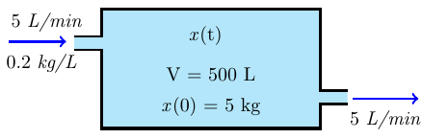























Concentration of salt in the tank after 10 *min*:

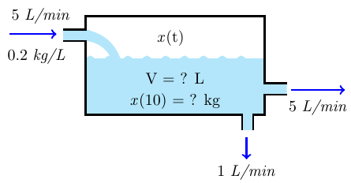 

1. 

































Concentration of salt in the tank after 20 *min*: 

***Exercise***

A tank of 100-*gallon* capacity is initially full of water. Pure water is allowed to run into the tank at the rate of , and at the same time brine containing  of salt per gallon flows into the tank also at the rate of . The mixture flows out at the rate of .

1. Find the amount of salt in the tank after *t* *minutes*.
2. How much salt is present at the end of 25 *minutes*?
3. How much salt is present after a long time?

***Solution***

1. 





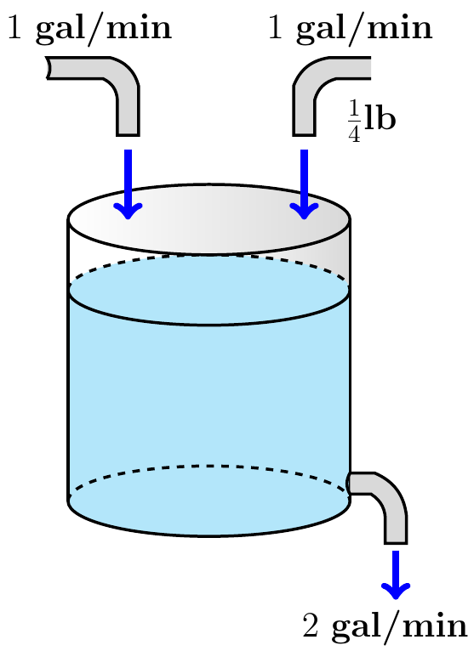

















1. 



1. 



As , the amount of salt is 

***Exercise***

A tank of 50-*gallon* capacity is initially full of pure water. Starting at time  brine containing  of salt per gallon flows into the tank also at the rate of . The mixture flows out at the rate of .

1. Find the amount of salt in the tank after *t* *minutes*.
2. How much salt is present at the end of 25 *minutes*?
3. How much salt is present after a long time?

***Solution***

1. 





















1. 



1. 



As , the amount of salt is 